# Assignment -4

Python Programming

| Assignment Date | 25 October 2022 |
| --- | --- |
| Student Name | S.Abirami |
| Student Roll Number | 953319104001 |
| Maximum Marks | 2 Marks |

# Question-1:

Write code and connections in wokwi for ultrasonic sensor.

Whenever distance is less than 100 cms send "alert" to ibm cloud and display in device recent events. Upload document with wokwi share link and images of ibm cloud

# Solution:

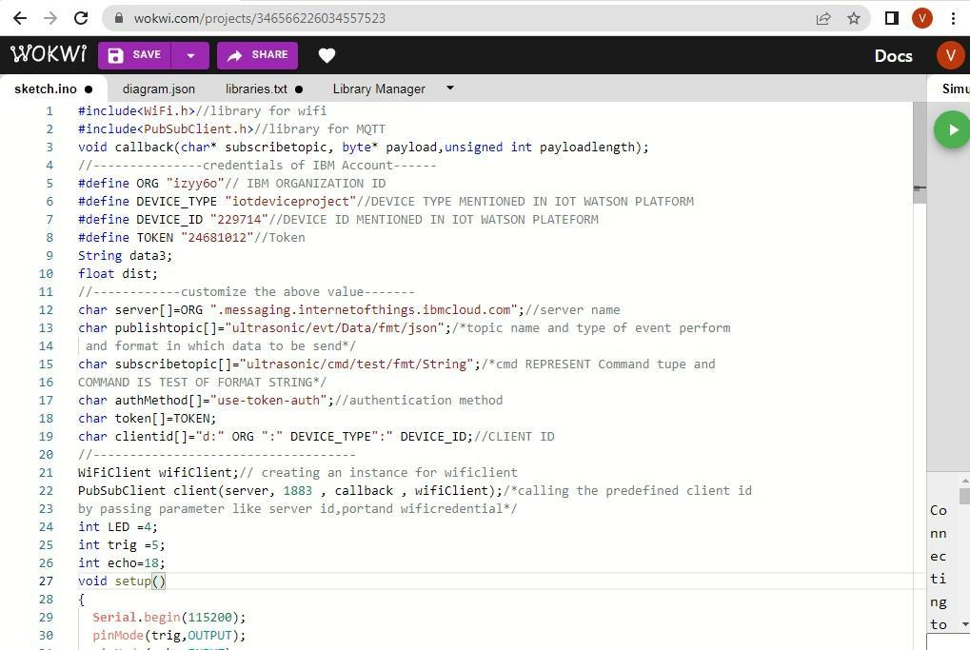

9 wolcwi.com/projects/3465662260345S7S23

sketch.ino B diagiarn.jsp libraries.at B Lbrary Manager

3't pi n £\Ode {echo, INRUT) ;

32 pi n £\Ode {LED, OUTPUT) ;

3 3 delay (IB);

1. ulfl connect ( ) ;
2. mqttconnect();

}



Simul

39 digitalkrite (trig,LON); se dig it at Nr te (tr 'ig, HIGH);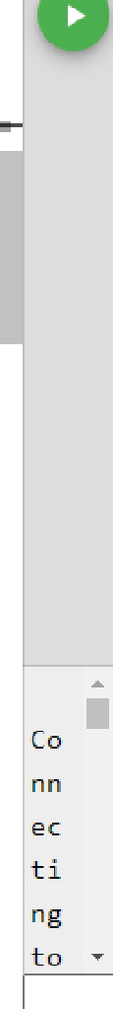

1. detayNicroseconds(10);
2. digitallJrite(trig,LOW);

4 3 f-laat dur- ouI sel n (echo,HIGH) ;

1. float dist=(dur * B . â343) /2;
2. Serial.pri nt ( ”dlstance in cm™ );
3. serîal.pri n (dist) ; a7 pub11shoata{dîst;

as deTay (taaa);

49 if ( ! client.IoDp( ) ) {

5» mqttconnect();

51 }

52 }

53 /’...............................................ret iving to cloud. */

1. voîd PubIîshData(float dist){
2. mqttconnect();//function caii for connecting to ibm
3. 6 /” c •e at ing I he st ping 1n fo pn a' 3 SON to update I he data to i bo cloud”/

58 if(dist<i00)

66 d ig it aI\v r'ite {LED, HI sH} ;

-+ C 0 . om/p‹oj pmsOs>zsov5s7s>3



sketch.ino B diagiarn.json libraries.b‹t B Lbrary Maroger -

1. SeriaI.pnintln("no object is near”);
2. object=”Hear";

63 }

64 else

65 {

1. digitalWnite(LED,LDW);
2. SeriaI.pnintln("no object found”);
3. object-"No" ;

69 }

70 String payload=”{\”distance\”:";



1. SeriaI . pr nt ( " S endi ng payloa d : " ) ;
2. Seria1. nt1 n (payload ) ;
3. i-F(client .publish(pubIishtopic. (char*) payload . c_str( ))}{
4. Serial . pP1nt1n( ”Publish ok™ ) ; /* i-f suces sfu I 1y upload data on the cloud then it will pnint

86 publish ok in sertaI moni t on or else it will print puDlish T ai ted* /

1. } else(
2. Serial.pnintln("Publish failed”);

83 }



1. vo id mqttco nnect ( )(
2. i-I-( ! c lient.connected( ) )(
3. Ser ial . p min I ( ”Reconnec tin g rent I o “ ) ;
4. Ser ial . p min t 1 n (server);

Simul



Co nn ec ti ng

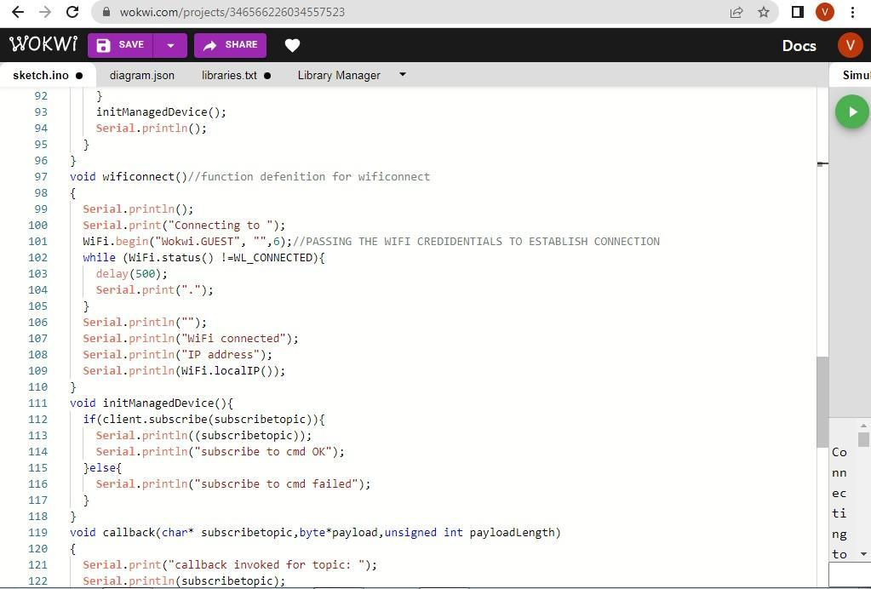

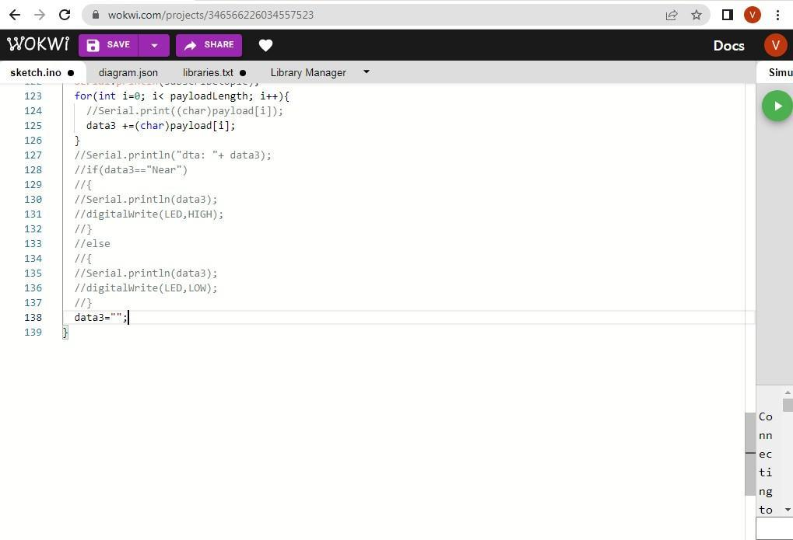

OUTPUT:

DATA IS SENT TO IBM CLOUD WHEN NO OBJECT IS DETECTED

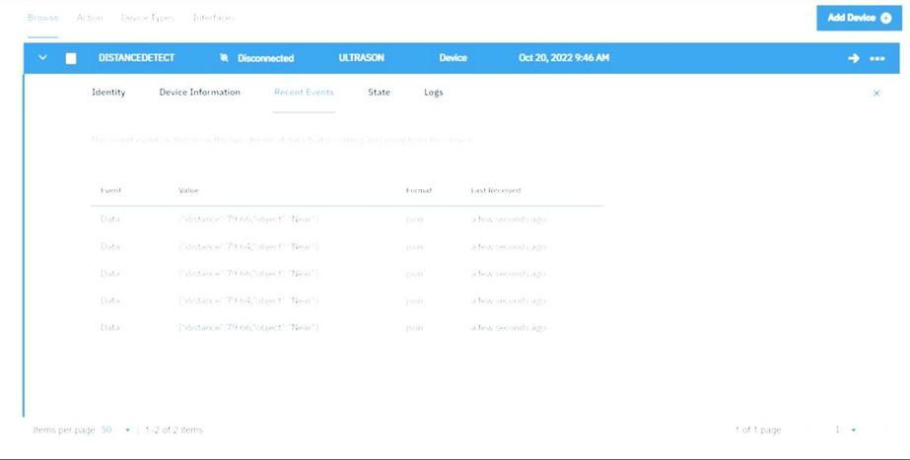

When no object is detected

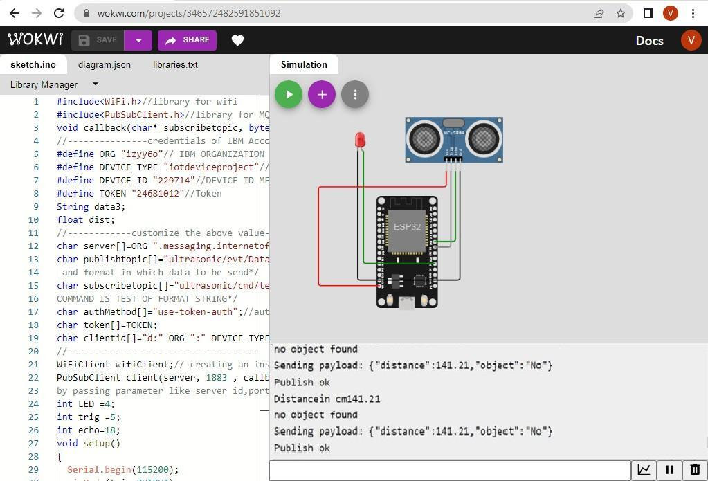

Data is sent to ibm cloud when object is detected



When object is detected in ultrasonic detector

